**Year 11**

**ATAR**

**Human Biology**

|  |
| --- |
| Name: |
| Teacher: |

|  |  |  |  |
| --- | --- | --- | --- |
| **Task 5: Digestive and Excretory Systems Test** | | | Weighting 5% |
|  | Marks Received | Marks Available | Percentage |
| Multiple Choice |  | 15 |  |
| Short Answer |  | 25 |  |
| Extended Answer |  | 10 |  |
| Total |  | 50 |  |

Time Allocated:

Reading time: 5 minutes

Working time: 50 minutes

**PART A: MULTIPLE CHOICE SECTION 15 MARKS**

1. Besides excreting harmful and unwanted substances the kidneys also:

a) deaminate proteins.

b) transform glucose into the polymer glycogen.

c) regulate the fluid content of the blood.

d) manufacture urea.

2. Which of the following describes the pathway of a waste molecule that is excreted by the kidney?

a) Bowman’s capsule 🡪 glomerulus 🡪 tubule 🡪 ureter 🡪 bladder

b) glomerulus 🡪 Bowman’s capsule 🡪 tubule 🡪 urethra 🡪 bladder

c) Bowman’s capsule 🡪 glomerulus 🡪 tubule 🡪 urethra 🡪 bladder

d) glomerulus 🡪 Bowman’s capsule 🡪 tubule 🡪 ureter 🡪 bladder

3. Consider the concentration of water in blood of the artery supplying the kidney and in the blood of the vein leading from the kidney. Which of the following statements is correct?

a) The concentration of water in the blood of the artery supplying the kidney is greater than the concentration of water in the blood of the vein leading from the kidney.

b) The concentration of water in the blood of the artery supplying the kidney is less than the concentration of water in the blood of the vein leading from the kidney.

c) There is no significant difference between the concentration of water in blood of the artery supplying the kidney and in the blood of the vein leading from the kidney

d) It is difficult to measure the concentration of water in blood of the artery supplying the kidney and in the blood of the vein leading from the kidney.

4. Consider the diagram below.

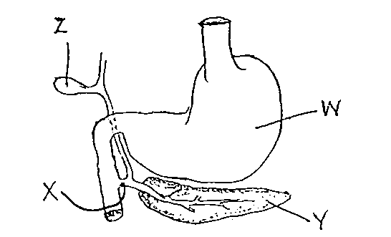

Which of the following pairs of substances pass through structure X?

a) hydrochloric acid and bile.

b) bile and pancreatic juice.

c) salivary amylase and intestinal juice.

d) gastric protease and hydrochloric acid.

5. The function of the villi and microvilli in the small intestine is to:

a) decrease the amount of exposed surface

b) increase the total area of enzyme retention

c) increase the total area for absorption

d) all of the above

6. Which one of the following nutrients, after digestion, could be expected to enter the blood stream via the lymphatic system?

a) starch

b) milk sugar

c) protein

d) fat

7. When passing from the stomach to the duodenum, food must pass through the

a) pyloric sphincter

b) oesophagus

c) bile duct.

d) cardiac sphincter

8. In the large intestine the following nutrients are absorbed.

a) amino acids and fats

b) water

c) carbohydrates and fibre

d) water, some minerals and vitamins

9. The intestinal enzyme that digests protein is:

a) maltase.

b) sucrase.

c) protease.

d) lipase.

10. The most effective and least harmful way of increasing peristalsis in order to prevent constipation is to:

a) eat more foods containing roughage.

b) drink smaller quantities of water.

c) take gentle laxatives.

d) refrain from exercising after meals.

11. The basic building blocks of lipids include:

(a) amino acids only.

(b) fatty acids and amino acids.

(c) fatty acids and glycerol.

(d) saccharides and glycerol.

12. Urine produced under normal conditions should contain:

(a) water, urea and uric acid.

(b) glucose, water and protein.

(c) water, sodium and protein.

(d) glucose, urea and water.

13. People with coeliac disease are unable to tolerate:

(a) A protein called gluten

(b) A carbohydrate called gluten

(c) A protein called glycogen

(d) A carbohydrate called glycogen

14. The organic nutrient with the highest energy content is:

(a) lipids

(b) proteins

(c) carbohydrates

(d) sugars

15. The location in the kidneys of Bowman’s capsule and Loop of Henle are:

(a) pelvis and medulla respectively

(b) medulla and cortex respectively

(c) cortex and medulla respectively

(d) Both are located in the medulla

**END OF PART A**

**Year 11**

**ATAR**

**Human Biology**

|  |
| --- |
| Name: |
| Teacher: |

**MULTIPLE CHOICE ANSWER SHEET**

For each question, shade the box to indicate your answer. Use only a blue or black pen to shade the boxes. If you make a mistake, place a cross through that square then shade your new answer. Do not erase or use correction fluid/tape. Marks will not be deducted for incorrect answers. No

marks will be given if more than one answer is

completed for any question.

|  |  |  |  |  |
| --- | --- | --- | --- | --- |
| **1** | a | b | c | d |
| **2** | a | b | c | d |
| **3** | a | b | c | d |
| **4** | a | b | c | d |
| **5** | a | b | c | d |
| **6** | a | b | c | d |
| **7** | a | b | c | d |
| **8** | a | b | c | d |
| **9** | a | b | c | d |
| **10** | a | b | c | d |
| **11** | a | b | c | d |
| **12** | a | b | c | d |
| **13** | a | b | c | d |
| **14** | a | b | c | d |
| **15** | a | b | c | d |

**PART B: SHORT ANSWER SECTION 25 MARKS**

**Complete each of the following questions in the spaces provided.**

**16.** There are several organs of the body which are involved in excretion of unwanted substances out of the body. Describe four of these by completing the following table.

(8 marks)

|  |  |
| --- | --- |
| Excretory organ | One substance excreted |
|  |  |
|  |  |
|  |  |
|  |  |

**17.** Parts (a), (b) and (c) of the question refer to the diagram of the nephron shown below.

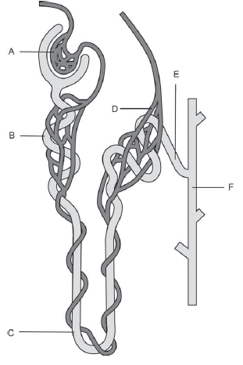

1. Identify the structures labelled ‘A’ and ‘D.’ (2 marks)

A: _____________________________________________

D:_____________________________________________

1. State the function of the structures labelled ‘B’ and ‘C’. (2 marks)

B:_________________________________________________________________________________________________________________________________________________

C:________________________________________________________________________________________________________________________________________________

(c) What functions does the structure labelled ‘E’ perform that affects the composition of

urine? (2 marks)

___________________________________________________________________________________________________________________________________________________________________________________________________________________________

(d) Name the organ of the body that produces urea. (1 mark)

________________________________________________________________________

**18.** Parts (a) and (b) of the question refer to the diagram of the digestive system below.

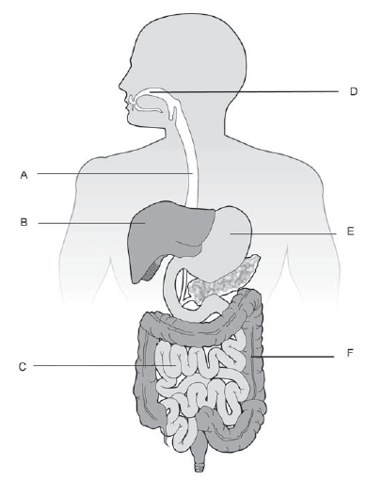

1. Identify the structures labelled ‘B’ and ‘C’. (2 marks)

B:_____________________________________________

C:_____________________________________________

1. Various functions of the digestive system are listed below. Match these functions with the labelled structures in the diagram on the previous page.

Some of the functions described may match more than one labelled structure. Make sure you list **all** the structures that perform that function. Use the **letters** from the previous diagram in your answer.

(4 marks)

Mechanical digestion:­­­­­­­­­­­­­­­­­­_____________________________________________________

Chemical digestion of carbohydrates_________________________________________

Absorption of nutrients and / or water:________________________________________

Bile production:__________________________________________________________

**19.** Kidney failure can happen suddenly but is more likely to develop over a period of years. Name two ongoing causes and two treatments for kidney failure. (4 marks)

_____________________________________________________________________________________________________________________________________________________________________________________________________________________________________________________________________________________________________________________________________________________________________________

**END OF PART B**

**PART C: EXTENDED ANSWER SECTION 10 MARKS**

20. The body produces three main nitrogenous wastes including urea.

1. List the other two nitrogenous wastes and their sources

(4 marks)

1. Explain the process of deamination in detail

(6 marks)

|  |
| --- |
|  |
|  |
|  |
|  |
|  |
|  |
|  |
|  |
|  |
|  |
|  |
|  |
|  |
|  |
|  |
|  |
|  |
|  |
|  |
|  |
|  |
|  |
|  |
|  |
|  |
|  |
|  |
|  |
|  |
|  |
|  |
|  |
|  |
|  |
|  |
|  |
|  |
|  |
|  |
|  |
|  |
|  |
|  |
|  |
|  |
|  |
|  |
|  |
|  |
|  |
|  |
|  |
|  |
|  |
|  |
|  |
|  |
|  |

**End of Test**